Comparing Public Sector Hospital Nurse Employment and Earnings across Countries

Silmara Coelho

CCT College Dublin

Computing.IT.Business

MSc in Data Analytics SB+/FT

Lecture(s)

*Marina Iantorno / John O’Sullivan*

*Sam Weiss*

*Muhammad Iqbal*

*David McQuaid*

Date *31/07/2027*

# Author Note

Contact information silmaraccoelho@gmail.com

**Acknowledgements:** I would like to express my deep gratitude to all those who supported me to make this project. I would just like to thank my teachers, friends and colleagues for their support. In particular, I would like to thank my mentor who is showing me the way to understand how the AI world works. Thanks very much for supporting me.

**Disclosure:** The author in this paper have no conflicts of interest to disclosures.

# Abstract

This research focuses on Ireland's Public Sector Employment, specifically within the nursing sector. The study aims to compare nurses' salaries in Irish hospitals with those in Australia, Canada, Chile, Japan, Mexico, Turkey, USA, and various European nations such as Belgium, Netherlands, Denmark, Spain, Slovenia, Poland, Czech Republic, France, Finland, Italy, Hungary, Estonia, Slovak Republic, Portugal, Iceland, and Norway. Factors such as GDP, cost of goods, exchange rates, location, income per capita, and average salaries are considered in the salary comparison to understand the differences in compensation among different healthcare professionals.

As of 2022, the average nurse salary in Ireland is $64,000 annually, ranking it third-highest among the countries studied. While Ireland's Public Sector Employment has garnered global attention, it is essential to recognize that salary figures may fluctuate and could have changed since the last update. Additionally, the context of each city and job must be taken into account when interpreting the findings, although the aim is to uncover insights that may be applicable to diverse populations. For up-to-date and accurate information, it is advisable to refer to recent salary surveys, government labor statistics, or reputable sources within the healthcare industry for specific locations of interest.

*Keywords:* **Nurse; Salary; Hospital; Ireland; Countries; Variable; Health**

# 

# Introduction

Nurses play an indispensable role in healthcare, providing compassionate care to vulnerable patients and contributing significantly to the well-being and recovery of individuals across various life stages. Their dedication to promoting direct patient care and achieving positive outcomes makes them crucial members of healthcare teams. However, there exists a concerning disparity in compensation among health professions that have a similar impact on patient care and well-being.

Nursing practices have continuously evolved to adapt to technological advances, changing patient needs, and evolving health system policies. With these advancements, it is reasonable to expect a corresponding increase in salaries that reflect the evolving responsibilities and demands placed on nurses. Understanding the factors that influence nurses' salaries in hospital settings is, therefore, critical to promoting fair and equitable compensation.

The motivation behind this study lies in empowering both novice and experienced nurses to navigate their careers more effectively. By exploring the various factors that shape nurses' compensation packages, including geographic location, experience, education, and institutional policies, we seek to provide nurses with valuable insights to make informed decisions about their professional journeys.

In this paper, we undertake a comprehensive examination of the factors influencing nurses' salaries, recognizing the pivotal role they play in healthcare delivery. Through this research, we aim to shed light on the disparities in compensation and highlight the invaluable contributions of nurses to society. By understanding the complexities of nurses' salaries and career trajectories, we hope to foster an environment that values and supports nursing professionals, promoting excellence in patient care and ultimately enhancing the overall quality of healthcare.

# 

# Methods

## Participants

Academic student: The study was conducted by a healthcare professional, studying MSc in Data Analytics SB+/FT. This Research aims to understand the factors that influence nurses' salaries and how they compare to other factors that involve and determine nurses' remuneration in different countries.

### Project Management framework selected: Waterfall

In choosing the project management (PM) framework, the Waterfall approach was selected over alternatives like Agile, Scrum, Adaptive, and Extreme Programming. The decision was primarily driven by considerations of time and human resources. While Agile strategies offer benefits such as adaptability and flexibility, the project's nature and constraints could be better addressed by a structured and linear approach like Waterfall. The Waterfall model provides a well-defined and sequential plan from start to finish, ensuring a clear roadmap and allowing for precise scheduling and resource allocation. This characteristic is particularly valuable given the limitations on time and personnel, as it enables efficient project planning and minimizes the need for constant reevaluation and adaptation during the execution phase.

Consequently, the project was approached in four stages / phases, each documented in one Notebook:

* *Notebook 1. Data Preparation
* *Notebook 2. Exploratory Data Analysis
* *Notebook 3. Statistical Analysis and Hypothesis Testing
* *Notebook 4. Machine Learning for Data Analysis

***Data Science Framework Selected - Knowledge Discovery in Databases (KDD)***

Among the various data science frameworks like CRISP-DM and SEMMA, Knowledge Discovery in Databases (KDD) was selected. The decision was justified by the linear nature of the KDD process, which involves sequential steps, thereby requiring less reprocessing compared to other strategies. Given the time and human resource limitations, the team saw KDD as a more efficient and manageable approach to extract meaningful insights from the data. The KDD framework offers a systematic and organized methodology for data analysis, making it an appropriate choice for the project's scope and resource constraints.

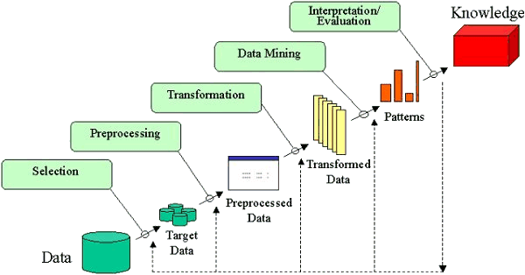

Figure 1. Knowledge Discovery workflow between phases of data maturity.   
Source: http://www2.cs.uregina.ca/~dbd/cs831/notes/kdd/kdd.gif

### Developing Environment - Jupyter Local

When selecting the developing environment, the team settled on Jupyter Local as the preferred choice, despite alternatives like Google Colab, Kaggle, and Deep Note. The main justification behind this decision was the time and human resource limitation, coupled with the fact that the project did not necessitate extensive collaboration among team members. Jupyter Local provides a suitable and efficient environment for individual work and data exploration. While other platforms may offer collaboration features, the team determined that Jupyter Local met their immediate needs without introducing additional complexities or dependencies on external platforms.

### Versioning

In terms of Git versioning, the decision was to upload only finished versions of datasets and notebooks. The primary justification for this choice was the consideration of time and the perceived risk associated with mastering Git efficiently. Given the project's resource constraints, the team decided to minimize the learning curve and potential errors that could arise from managing version control extensively. Uploading only finished versions ensures that the project's progress and deliverables are tracked effectively without the need for continuous management of versioning throughout the development process.

### Timeline (Gantt Chart)

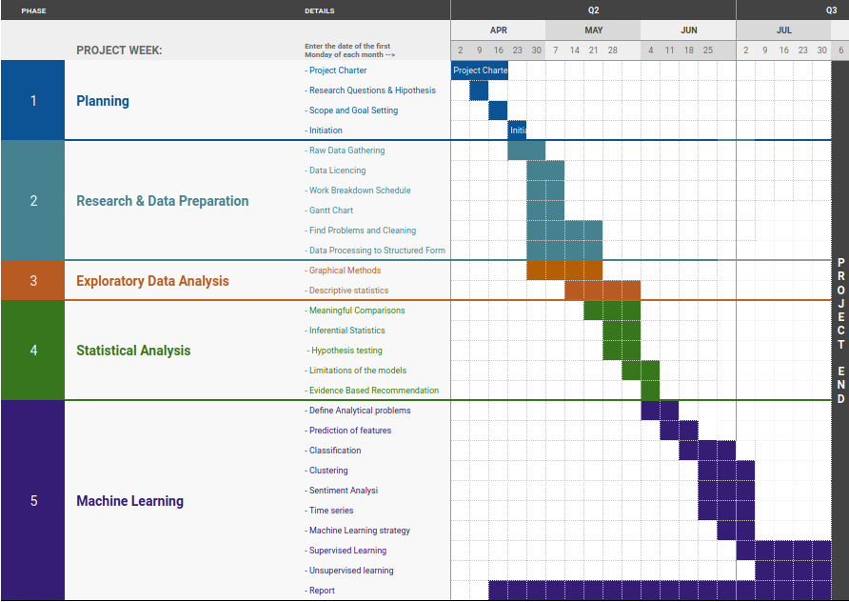

Figure 2. Timeline of the project

## 

## Assessments and Measures

The process typically begins with data collection, where relevant data is gathered from various sources. Once collected, the data undergoes a critical step called Extract, Transform, and Load (ETL), where it is cleaned, formatted, and prepared for analysis. Exploratory Data Analysis (EDA) is the next step, where data is summarized and visualized to gain insights into its distribution, patterns, and relationships. During this phase, outliers are identified and handled to ensure data accuracy. After EDA, statistical analysis comes into play. I aim to use hypothesis testing, regression analysis, and descriptive statistics to draw meaningful conclusions and make predictions based on the data. These analyses provide valuable insights into research questions and help uncover significant relationships within the dataset.

Graphical analysis complements statistical analysis by presenting the findings visually. Data visualization techniques such as charts, graphs, and interactive dashboards enable a clear and concise communication of the results, making complex data more accessible and understandable to stakeholders. Throughout the process, interpretation and insights are drawn from the analyses, guiding decision-making processes and informing strategies. This iterative process ensures that the data analysis is robust and takes into account different perspectives and alternative approaches.

### 

## Data Preparation

### Raw Data Gathering

Datasets were gathered from the Organization for Economic Co-operation and Development (OECD)[1]. The data collects information about 39 countries that report the salaries of different categories of nurses in public hospitals and other facilities. Data was present in XML form, as a file from the OECD website. The data did not carry a dictionary, so it was necessary to research what were the meaning of each variable, its estimated ranges and if its interpretation were of any use for this project.

#### Assumptions

* Data Source Reliability: Assuming that the OECD, being a reputable international organization, provides reliable and accurate data on nurse salaries from various member countries.
* Consistent Data Collection: Assuming that the data on nurse salaries were collected using consistent methodologies and definitions across all countries, ensuring comparability.
* Currency and Time Period: Assuming that the data is up-to-date and reflects nurse salaries for a specific time period, allowing for relevant comparisons.
* Full Coverage of Countries: Assuming that the dataset covers a comprehensive range of OECD member countries, providing a representative sample for analysis.
* Inclusion of Benefits: Assuming that the dataset includes comprehensive compensation information, including benefits and allowances, to provide a complete picture of nurse salaries.
* Currency Conversion Accuracy: Assuming that currency conversion rates used to standardize salaries are accurate, allowing for meaningful cross-country comparisons.
* Data Privacy Compliance: Assuming that the OECD follows strict data privacy regulations and safeguards to protect the confidentiality of individual nurse salary information.
* Comparable Job Roles: Assuming that the dataset considers similar job roles and responsibilities of nurses across countries to ensure meaningful salary comparisons.
* Data Consistency: Assuming that the dataset is free from significant data entry errors or inconsistencies that could affect the accuracy of salary information.

Making assumptions about a dataset's trustworthiness and reliability involves evaluating critical factors to ensure data quality. Firstly, a reputable source, like a government agency or established research institution, boosts credibility. Secondly, transparency in data collection methods, sampling, and potential biases enhances trustworthiness. Cross-validation with reliable sources and historical trends validates consistency. The absence of significant missing values or outliers indicates careful data handling. Adherence to data privacy and ethical guidelines ensures reliability and confidentiality. Considering these factors allows reasonable assumptions about the dataset's trustworthiness and reliability.

#### Some interesting findings about the dataset are:

* Nurses, contrary to other professions, have no data for self-employed incomes.
* Not all the measure values are in dollars, some are in many different NCU (National Currency Unit). However, there is a conversion to the dollar. We had to check how that conversion was calculated
* Adjusting for inflation was made using GDP price level to 2015 prices[2]
* Also, in order to compare cost of life, it includes an adjustment of salaries using PPP. [3]
* A measure of how good a salary is compared to the rest of the population in the country[4][5]
* Most of the countries report data for years 2010 to 2020, some countries do not report 2021 and or 2022, and some countries report less than 6 years. There are countries that report every 2 or 4 years. Some countries like the USA only report data for nurses and nothing about other professions. So, the data is unbalanced and incomplete, however data is very clean and when complete seems reliable.
* Most of the countries have their data flagged. The exact meaning of the flags, as estimated value; Break; Difference in methodology and provisional value is not completely clear. As most of the countries may be using a different methodology to calculate the values I opted to ignore the flags, and trusted no the data as it is, because the alternative is to gather many other different sources (GDP, Inflation, exchange rates, PPP, etc.) to recalculate and fix all the data with the same methodology.

### Find Problems and Cleaning

The data had no problems of Encoding or **format.** And all the data in the dataset was more or less consistent, except for the flags that marked a difference in meaning or sourcing.

#### Relevance

Some of the data is not useful to make appropriate comparisons: data in national currencies, as well as data that is not deflated or has some kind of adjustments to account for Purchase Power, price Index or any other difference between countries.

Also, many countries had not complete data for all the professions or all the time frames. Some of them were not considered and some of them were estimated based on a linear interpolation when the data present had periodicity to do that.

The flags were studied and it was concluded that their meaning was vague and as a 5th of the data was flagged, the flags corresponded to particular countries. The problem was: We can compare only countries with a certain flag, or countries without flag, but the variability between countries would be greater, so any conclusions based on that analysis would be linked more to dissimilarity between countries than to difference in methodology to gather data. At the end we make the assumption to not consider the flags as an important indicator variable, because its meaning would be obscure.

#### Data Augmentation and enrichment

We calculate the salaries, converted to US dollars, and adjusted for inflation using the GDP price index for 2015 in order to make the data in the same unit and also comparable over time. However, comparing countries is a complex task that requires considering various factors and dimensions. The most useful ways to compare countries include:

1. Economic Indicators: Comparing countries based on economic indicators such as Gross Domestic Product (GDP), GDP per capita, inflation rates, unemployment rates, and trade balances can provide insights into their economic health and performance.
2. Human Development Index (HDI): HDI combines indicators like life expectancy, education, and income to assess a country's overall human development. It offers a more comprehensive view of a nation's well-being beyond just economic factors.

So, in order to help visualize the countries we included their 2022 GDP ranking as an ordinal feature, embedded in the name of the country. This way we can order countries by their similarity in GDP. It is not a very thoughtful procedure, but it helps in comparing similar boxplots and histograms side by side.

Missing data was problematic. We interpolated the data using as references the previous and the next value, in order to generate an estimation. We assume that this estimation is not affecting the dataset too much, because the dataset already has many estimated data points.

#### Handling Outliers

There are indeed many outliers. However, it depends on the point of view. If we calculate the outliers for a particular profession, type of employment and country, we have only 10-13 data points corresponding to the years that is not too much. Also, if we look at the outliers that fall outside the general distribution of the data, then there are no outliers, because the differences in salaries between countries, or between different professions or between types of employment are so wide. In the end, no outliers were eliminated from the dataset.

### Data Processing to Structured Form

There was two datasets produced:

HEALTH_REAC_Interpolated.csv A dataset with missing data filled and all data flagged

HEALTH_REAC_Augmented.csv A dataset only with data needed, and enriched with new variables.

## Exploratory Data Analysis (EDA)

Using graphical methods and descriptive statistics we evaluate each of the research questions proposed. These comparisons will be based on public hospitals, which is the data publicly available and it can be assumed that the data is more comparable than including other private hospitals and clinics with varying degrees of standards of service,

#### 1. What is the average salary of nurses?

The average nurse salary is a variable that varies widely. As seen in the plots below, After analyzing the data, it is possible to perceive a huge salary difference between nursing professionals influenced by several factors, such as level of experience (specialization), education (specialization), type of employment, and location (country).

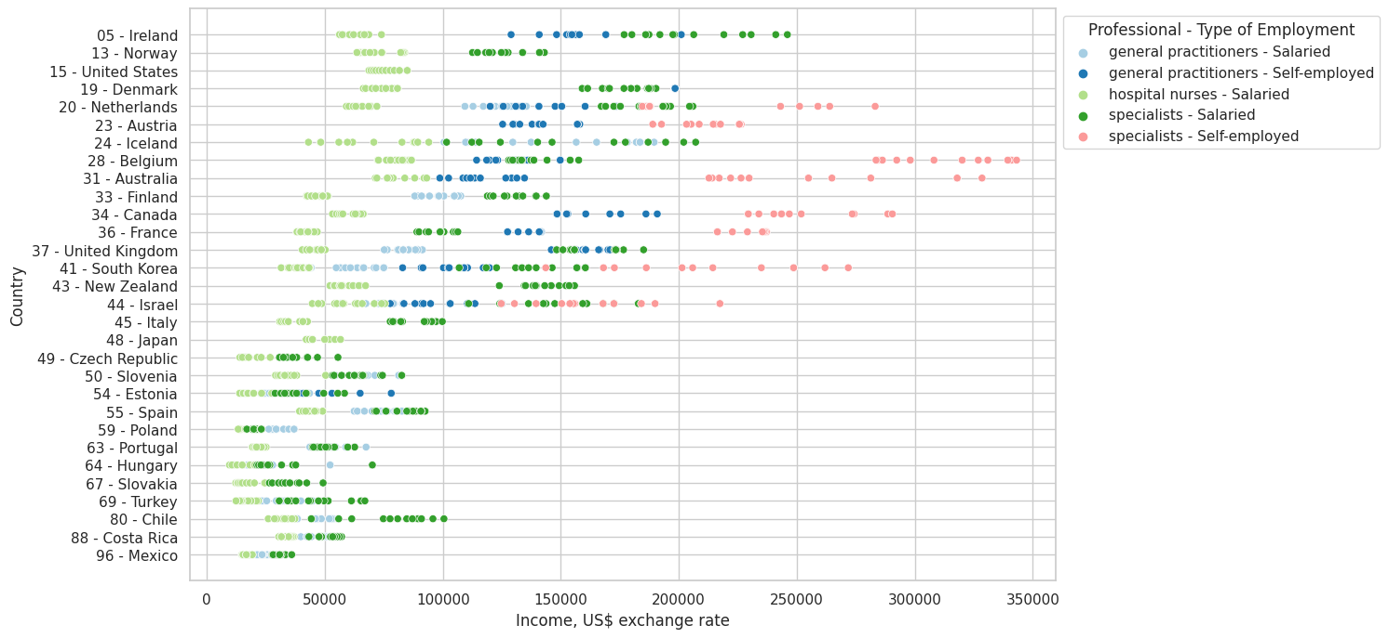

Figure 3. Variation of salaries depending on country, specialization and type of employment.

The average salaries have to be compared in absolute terms that means, converted to the dollar. Also, it may be useful to adjust the salaries to the size of the economy of each country (GDP), for the cost of life, index of prices, and purchase power (PPP), and compare the salaries among other salaries in the country (income per capita or average salary). Also, adjusting for inflation (2015 price level).

|  |  |  |  |  |  |
| --- | --- | --- | --- | --- | --- |
| **Measured_Unit** | **Income per average wage** | **Income / per capita GDP** | **Income PPP for private consumption, in US$** | **Income, US$ exchange rate** | **Income at 2015 GDP price level, in US$** |
| **Datapoints count** | 1170 | 1170 | 1170 | 1170 | 1170 |
| **mean** | **2.33** | **2.53** | **$ 91187** | **$ 91956** | $ 90440 |
| **std** | 1.15 | 1.37 | $ 57811 | $ 67751 | $ 67464 |
| **min** | 0.76 | 0.59 | $ 15112 | $ 9605 | $ 2677 |
| **25th percentile** | 1.32 | 1.41 | $ 47853 | $ 38960 | $ 38550 |
| **50th percentile** | 2.19 | 2.35 | $ 73830 | $ 70962 | $ 69676 |
| **75th percentile** | 2.94 | 3.26 | $ 127379 | $ 134912 | $ 133773 |
| **max** | 7.62 | 8.52 | $ 337931 | $ 343097 | $ 360216 |

Table 1. Descriptive Statistics of the numerical features of the dataset: Salaries are in US Dollars

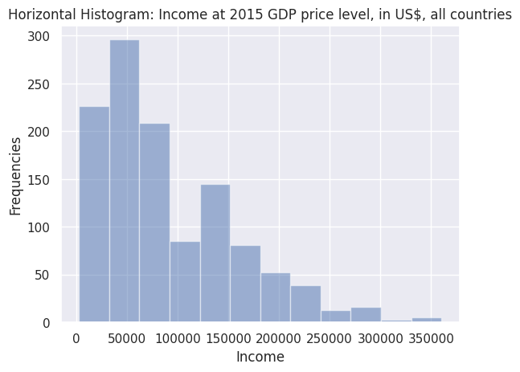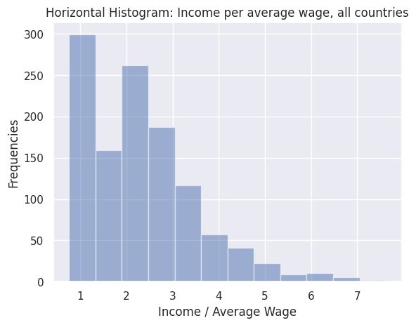Figure 4. And 5. Histogram of the income in US$ (adjusted for inflation) and compared against average wage.

We can see that the distribution is skewed to the left that means that most of the salaries in the countries studied tend to be around US $50.000, and tend to be between 1 and 2 times the average salary for the country.

#### 2. Are there significant regional variations in nurse remuneration?

Discriminating by country, the picture changes, as seen in figure 6: the variation is too wide. Also, we can see a correlation between GDP (the countries are ordered by GDP) and income. Furthermore, we can see how the salaries vary when compared against income per capita and average wage. The latter comparison is more useful because it doesn't take into account the part of the GDP of a country that is not related to salaries. Income against average wage takes in consideration only wages.

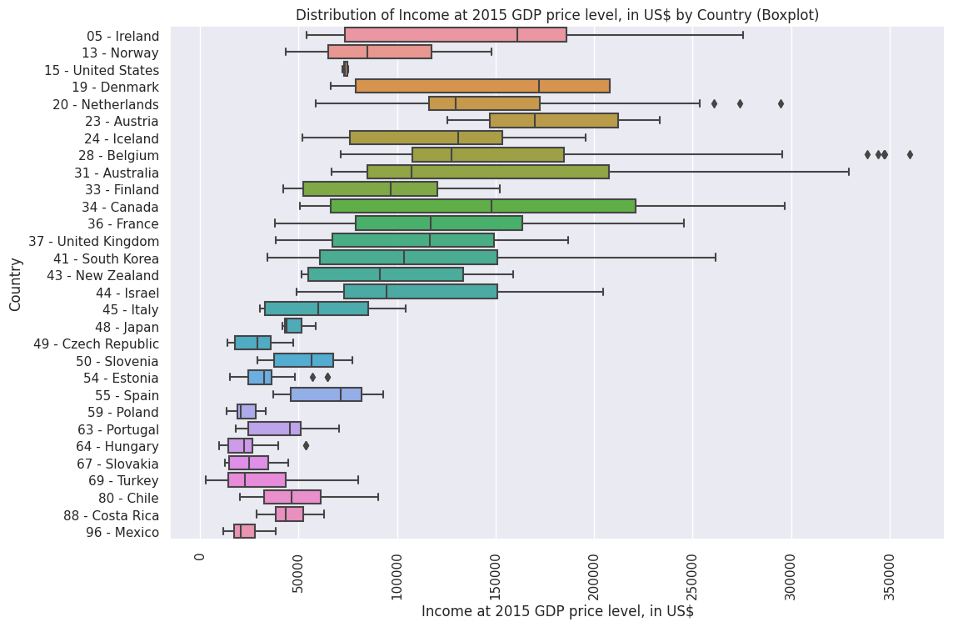

Figure 6. Distribution of salaries in different countries. Countries are ordered by their ranking in GDP per capita

Another important point is to be able to see the differences in income distribution between developed and developing countries. In this study, data is limited to the countries with the best reporting, and they happen to be into the first 80 of 200 countries, ranked by GDP. The graphs show an important trend: salaries are positively correlated with GDP, however, in Latin America specially, nurse salaries are better than salaries of general population, and this trend is not existent present in the majority of the more developed countries.

#### 

#### 3. In which of the countries, nurses are the highest paid?

Nurses' salaries can vary greatly in each country, this involves several factors, economics, qualification, experience, health policy in each country and demand for professionals. Rich countries like nurses receive better remuneration and also the demand for qualified professionals and specialists is also greater. As can be seen in the specified in the chart below.

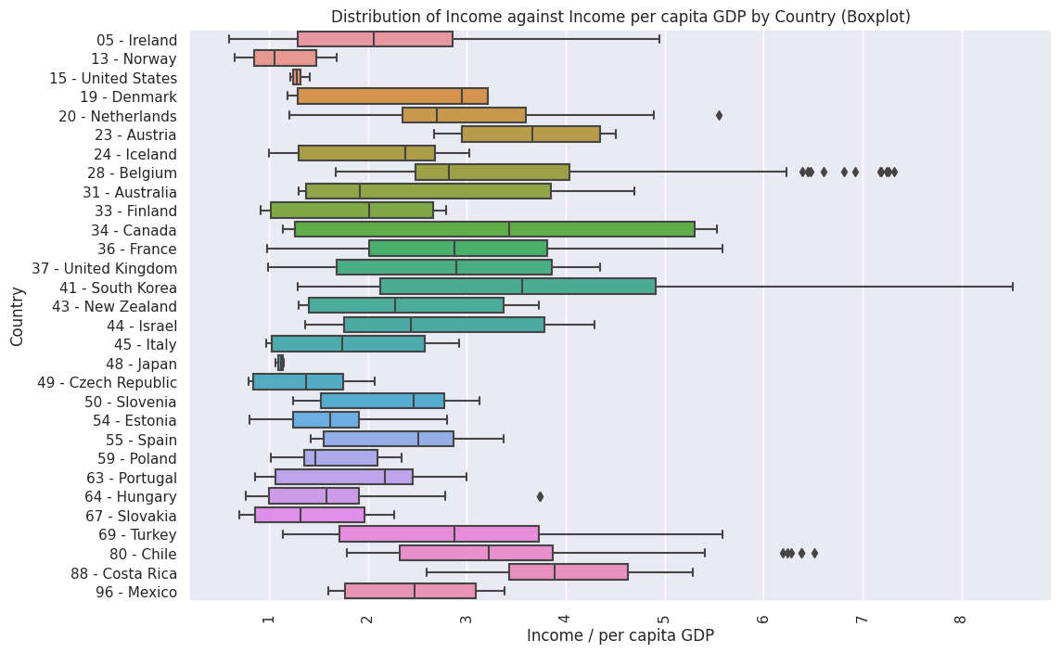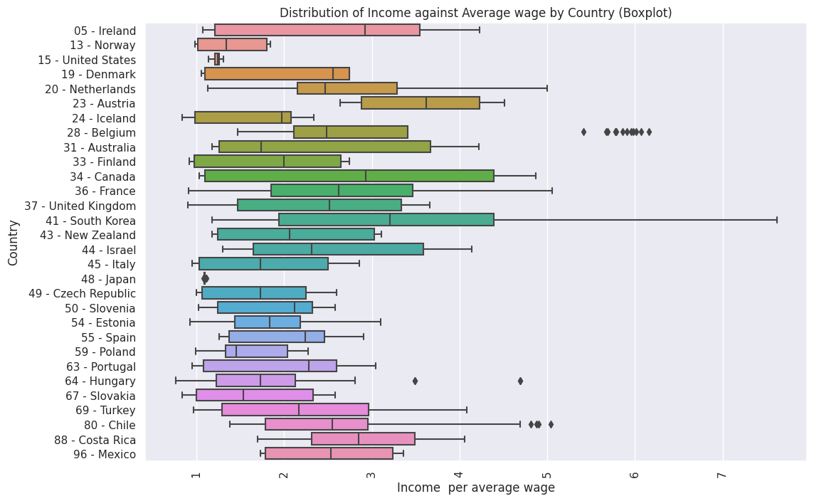

Figure 7. Income compared to the income per capita. Figure 8. Income compared to the average income in different countries. Countries are ordered by their ranking in GDP per capita

Comparison of salaries normalized, and over time

Comparison of salaries vs income per Capita for countries, too

Clusters of countries by similarity

Cluster of countries by methodology

Only consider countries data when balanced and complete

#### 4. How has the remuneration of nurses evolved within the last twelve years?

Figure 11. Variation in Income (Adjusted for inflation and converted to US $) for different professions

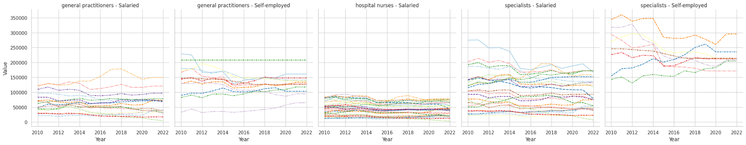

Figure 12. Variation in Income (Adjusted for inflation and converted to US $) for each country,   
separated for different professions

We have chosen to analyze the income adjusted for inflation and converted to the dollar. It does not take into account economic differences between countries. What we have found is that salaries have stagnated for hospital nurses.

For general practitioners they have rise or fall depending on the country, and for specialists, they have been getting lower. In the case of the self-employed population we see a trend of stabilization of salaries between countries towards similar salaries. We do not know the reason for this trend yet.

#### 5. How does education level (qualifications) and experience affect nurses' salaries in hospital settings?

The wage gap for nurses varies based on education, location, and hospital policies. Some regions or hospitals may value education more than others. Experience and qualifications also impact nurses' salaries, with advanced degrees and training leading to higher earnings and more opportunities for professional growth and job satisfaction. Education not only benefits individual nurses but also improves patient care and outcomes in hospitals.

However, with the data we have, we can only separate between three levels of specialization of nurses (hospital nurses, general practitioners and specialists) and two types of employment.(salaried and self-employed) that we assume, by domain knowledge that are correlated with experience and education. We can reformulate the question in some other ways:

* ***What is the distribution of income across different professions?***
* ***How does the income vary across different professions (hospital nurses, practitioner’s nurses and specialist nurses)?***
* ***Are there any correlations between a person's profession and their income level?***

Comparing the salary of the general practitioner nurses and the specialist nurses in the plot, we can see that the distributions are not overlapping. We have clearly different populations:

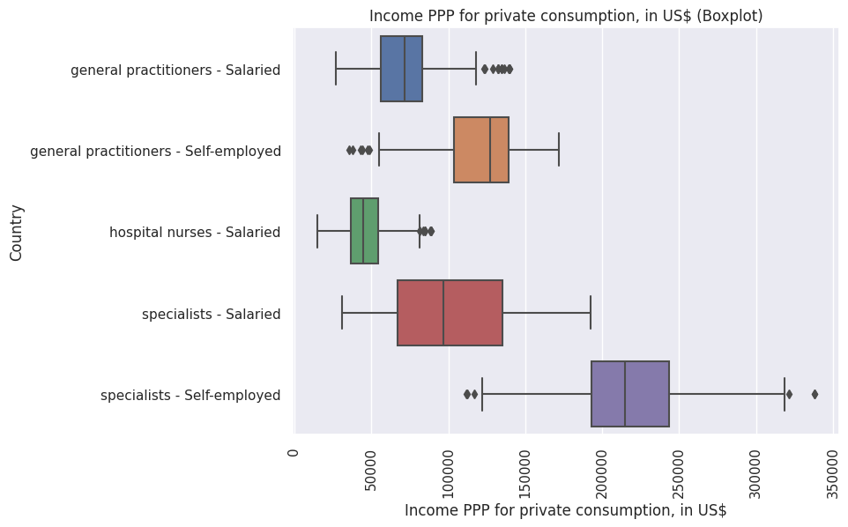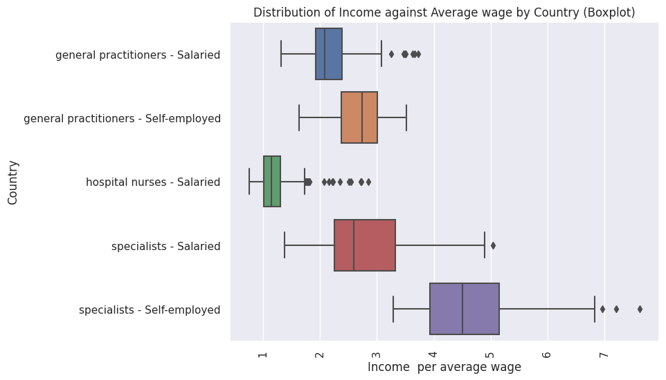

Figure 9. Income adjusted for Purchase Power (PPP) for different professions. Figure 10. Income compared to the average wage of the country, for different professions.

There is a huge difference between nurse practitioners and specialist nurses. On average, general practitioners earn 40% more than hospital nurses, and specialists 100% more. When those specialists and general practitioners transition to a self-employed mode, they can earn an additional 120% more.

In making this comparison between nurse practitioners and specialist nurses, we must consider and compare wage gap factors between independent nurses and nurse practitioners. In addition, we should know that nurses' salaries can change over time due to changes in health policies, economic conditions and demands in the evolution of the health and nursing system. For the most accurate salary information, we need to do constant nursing salary surveys, analyze government statistical data, reputable nursing care compensation reports specific to region and countries, and also do studies based on health and nursing systems.

#### 6. How do hospital nurses' salaries compare to the average salaries of health professionals in public hospitals?

Comparison between hospital nurse salaries and salaries of other healthcare professionals in the same hospital can vary based on factors such as, qualifications and responsibilities of the healthcare professionals involved. To make this comparison, we need to compare and take into account some specific points. Professional requirement, qualification, economy, regional experience, health policy and rich countries and poor countries all these questions must be considered.

In this case what we can compare is the income with the income per Capita and the average income. We found that salaries for hospital nurses are and have been historically around 1.2 times the general population. This means that those salaries are similar to salaries for unskilled labor. In contrast, general practitioners earn more or less 2.5 times what the general population earns, and specialists earn 5.2 times more than the average.

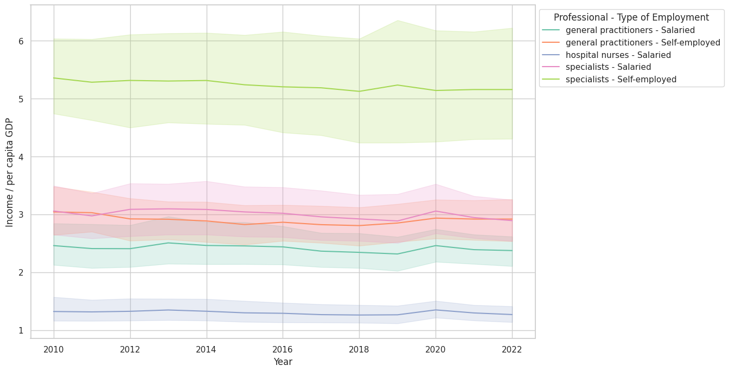

Figure 13. Variation in Income against income per capita, for different professions

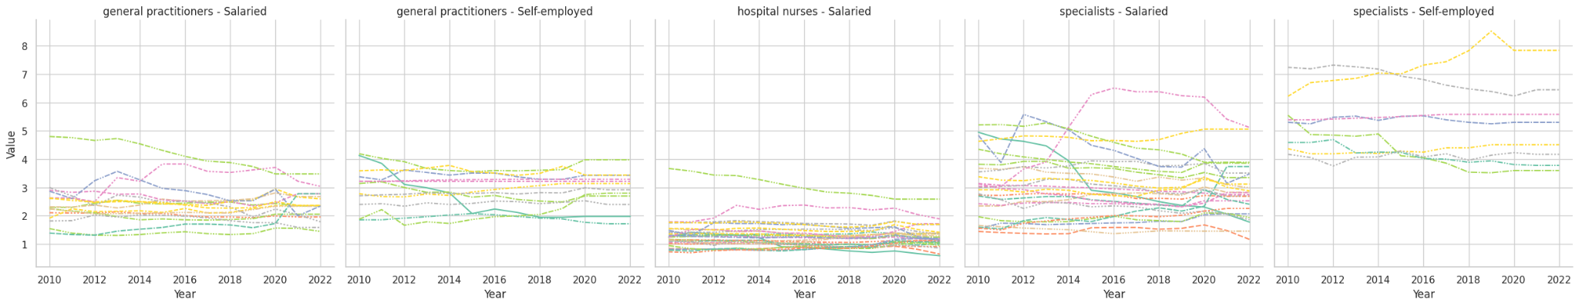

Figure 14. Variation in Income vs Income per Capita, for each country,   
separated for different professions

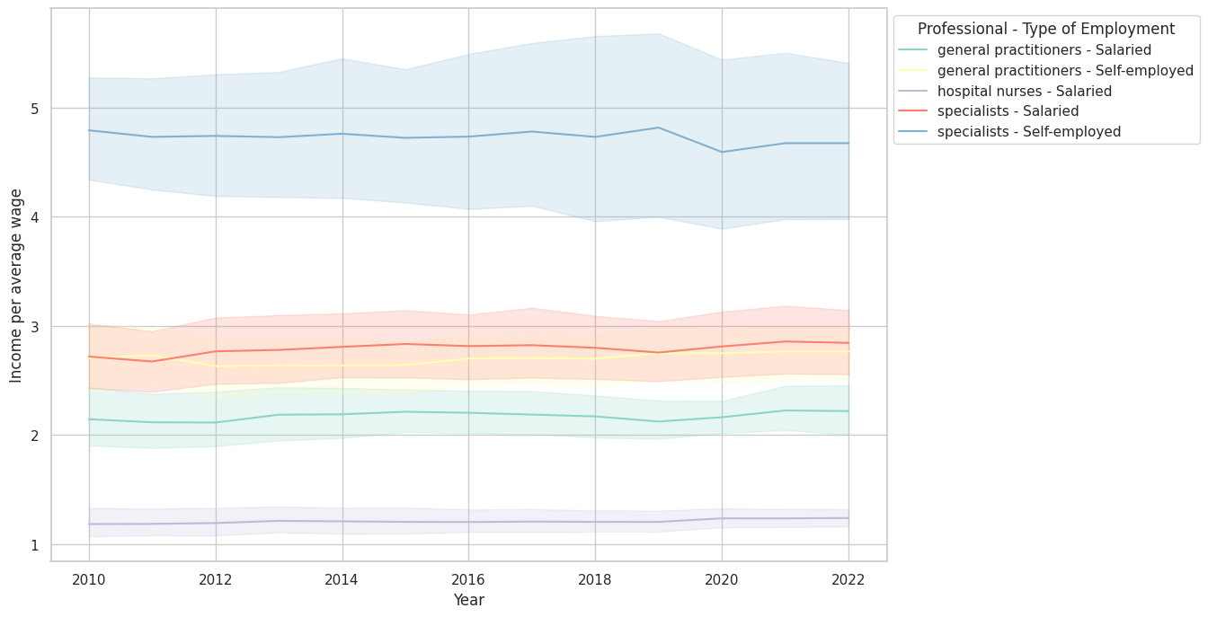

Figure 15. Variation in Income vs Average wage for different professions

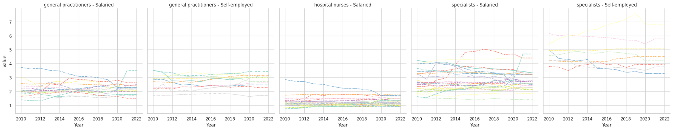

Figure 16. Variation of Income vs Average wage for each country,   
separated for different professions

#### 

### 

### Issues and Critique the Dataset

There are lots of problems with the dataset:

* The flags mark that almost have the dataset has been gathered with a different method.
* Some of the variables does not have a clear interpretation
* Some professions, some years, some countries data is missing.
* Data is heteroscedastic (It has non homogeneous variance).

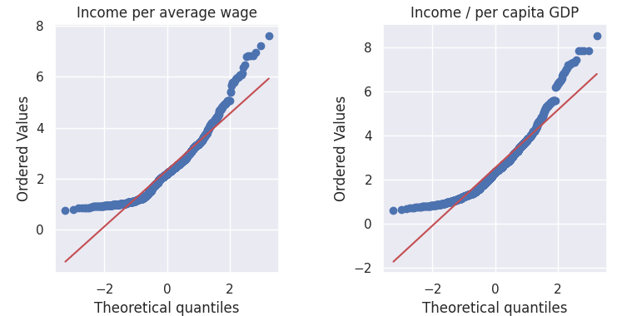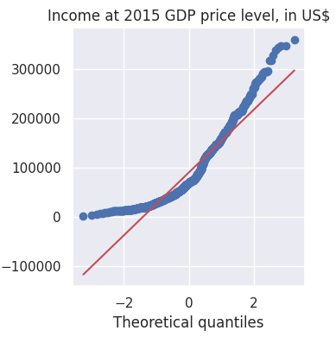

Figure 17. to 19. Q-Q plots to assess normality of the distributions of the variables and its outliers. If distribution is normal the plot should be a straight line.

#### 

#### Correlations

Due to the nature of the data, all the numerical variables are correlated: it is the same salary, but corrected by some factor or other. Also, all the salaries and the GDP of the country are correlated.

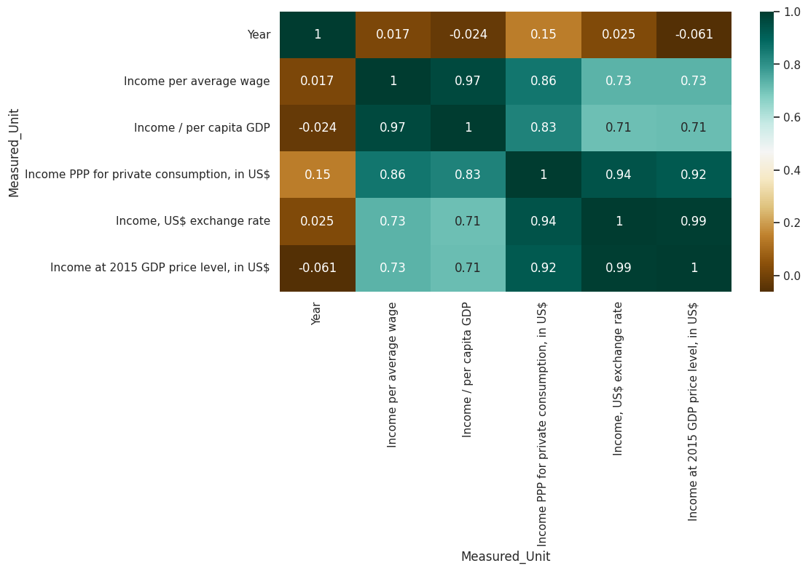

Figure 20. Correlations Matrix between all the numerical variables in the dataset

In this case, we would need more data. Trying to make a further correlation analysis with this data will not be of much interpretability. On the other hand, we can do some regression analysis (linear, multiple or logistic) in order to predict income based on Year, Profession specialization, type of employment and country

## Statistical Analysis.

#### Evaluate hypothesis

Applicability of tests (T-test, Anova, Chi-Squared) is not always feasible, because most of the assumptions needed are not met. We use some non-parametric tests (Wilkoxon, Kruskal-Wallis)

These test just confirmed what was already visible in the graphical analysis.

### 

## Machine Learning Algorithms

With the given dataset, several analytical problems can be addressed using machine learning algorithms. Here are some potential problems along with the corresponding machine learning algorithms that can be used to solve them:

1. **Income Prediction**: Predicting a person's income based on other variables like employment type, country, year, and economic indicators.
   * Algorithms: Linear Regression, Decision Tree Regressor, Random Forest Regressor.
2. **Country Classification**: Classifying countries based on their economic indicators and average wages.
   * Algorithms: Logistic Regression, Decision Tree Classifier, Random Forest Classifier, Support Vector Machine (SVM).
3. **Employment Type Prediction**: Predicting the type of employment (e.g., full-time, part-time) based on other variables.
   * Algorithms: Logistic Regression, Decision Tree Classifier, Random Forest Classifier, k-Nearest Neighbors (k-NN).
4. **Outlier Detection**: Identifying unusual or extreme data points that deviate significantly from the rest of the data.
   * Algorithms: Isolation Forest, One-Class SVM, Local Outlier Factor (LOF).
5. **Time Series Forecasting**: Predicting income trends over time for specific countries or employment types.
   * Algorithms: Time Series models (e.g., ARIMA, SARIMA, Prophet).
6. **Cluster Analysis**: Grouping similar countries or individuals based on their income and economic indicators.
   * Algorithms: K-Means Clustering, Hierarchical Clustering.
7. **Feature Importance**: Identifying which features have the most significant impact on income levels.
   * Algorithms: Feature Importance from Decision Trees, Permutation Importance.
8. **Dimensionality Reduction**: Reducing the number of features while retaining most of the information to simplify analysis or visualization.
   * Algorithms: Principal Component Analysis (PCA), t-Distributed Stochastic Neighbor Embedding (t-SNE).
9. **Anomaly Detection**: Identifying unusual patterns or deviations in income or economic indicators.
   * Algorithms: Auto encoders, One-Class SVM, Local Outlier Factor (LOF).
10. **Regression Analysis**: Modeling the relationship between income and other economic indicators.
    * Algorithms: Linear Regression, Ridge Regression, Lasso Regression.

### 

## 

## 

# Results

## Outcome 1: Comparing nurses' salaries across countries

We find striking similarities as well as significant differences that shed light on different approaches to remunerating nursing professionals in different parts of the country and around the world. These variations are influenced by factors such as economic conditions, health policy systems, government policies and the valuation of nursing as a professional.

Cross-country comparisons highlight the diverse global landscape of nursing salaries, reflecting socioeconomic and health system characteristics.

## Outcome 2: Comparable average salary ranges for nurses, among developed countries

Existing similarities median salary ranges for nurses: Despite different economic conditions, many countries tend to have comparable average salary ranges for nurses. In developed countries such as the United States, Canada, United Kingdom and Australia, Ireland, Luxembourg, among others, the average salary of nurses is generally higher than in developing countries.

## Outcome 3: Compensation based on experience and qualification

Most countries adopt a compensation scale based on experience and qualification, in which nurses with more years of service receive higher salaries. This practice aims to reward dedication and encourage experienced nurses to remain in the profession.

## Outcome 4: Competitive salaries as a consequence of Demand

Demand for hospital medical care: In countries facing high demands for scarce medical care or nursing staff shortages, efforts to attract and retain nurses are often reflected in competitive and attractive salaries and benefits.

## Outcome 5: Competitive salary limit in developing countries

Economic disparities: Developing countries face a major challenge in offering competitive salaries for nurses due to limited resources, challenging economic conditions to provide these benefits. This situation can lead to a shortage of nurses who migrate to other countries in search of better wages and quality of life, which will automatically affect the country's health system.

## Outcome 6: Cost of living

Discrepancies in the cost of living across countries directly influence nurses' salaries. The higher cost of living in certain regions and countries may require higher salaries for nurses to maintain a decent standard of living.

## Outcome 7: Value attributed to nursing

Valuation of nursing in different cultures: The social perception and value attributed to the nursing service can vary greatly between countries. In some cultures, nursing is often considered and rewarded financially, while in other cultures and countries it may be undervalued and inadequately compensated.

Addressing salary disparities is essential for improving recruitment, retention, and job satisfaction among nursing professionals.

## Outcome 8: Unionization and Collectivity in the nursing service

The constant presence and strength of nursing unions, collective bargaining efforts can positively and significantly impact nurses' salaries. Countries with strong community unions often negotiate better salaries and benefits for nursing staff. In conclusion, meaningful cross-country comparisons reveal a diverse global landscape of salaries in the nursing sector, reflecting unique socioeconomic, cultural, and health system characteristics. While there are commonalities such as experience-based pay and median salary ranges, professional qualification disparities highlight the challenges faced by the nursing profession in different regions and countries. Recognizing and addressing these discrepancies is essential to improving recruitment, attracting new nursing professionals, and also maintaining retention and overall job satisfaction. And lastly, ensuring fair and competitive compensation for nurses is critical to maintaining a robust nursing workforce and, more importantly, providing and maintaining the best possible care for patients around the world.

# Discussion

In this project, we explored the wage gap between independent nurses and specialist nurses in hospital settings, identifying several influential factors on nurses' salaries. Specialist nurses with advanced diplomas and autonomous functions command higher salaries due to increased responsibility in patient care. Specializations, demand for specific skills, and complexity of functions also impact specialist nurses' earnings.

Geographical location plays a significant role in salary variation, with regions facing nursing shortages offering higher compensation to attract and retain professionals. Experience and knowledge in nursing positively correlate with salary, while the healthcare environment's demand for specific specialties further influences earnings.

Collective bargaining agreements can also impact nurses' salaries, with those effectively negotiating pay and benefits securing higher remuneration. Overall, understanding these factors is crucial for healthcare organizations to ensure fair and competitive compensation, supporting nursing professionals' contributions to patient care and the industry as a whole.

# References

[1] OECD (2019), Recent Trends in International Migration of Doctors, Nurses and Medical Students, OECD Publishing, Paris, <https://dx.doi.org/10.1787/5571ef48-en>.

[2] OECD (2016), Health Workforce Policies in OECD Countries: Right Jobs, Right Skills, Right Places, OECD Health Policy Studies, OECD Publishing, Paris, <https://dx.doi.org/10.1787/9789264239517-en>.

[3]Aiken LH, Clarke SP, Sloane DM, Sochalski J, Silber JH. Hospital nurse staffing and patient mortality, nurse burnout, and job dissatisfaction. JAMA. 2002;288(16):1987–1993.

[4]Buerhaus PI. The potential imposition of wage controls on nurses: A threat to nurses, patients, and hospitals. Nursing Economics. 2008;26(4):276–279.

[5] Kutney-Lee A, Wu ES, Sloane DM, Aiken LH. Changes in hospital nurse work environments on nurse job outcomes: An analysis of panel data. International Journal of Nursing Studies. 2013;50(2):195–201

[6] Needleman J, Hassmiller S. The role of nurses in improving hospital quality and efficiency: Real-world results. Health Affairs. 2009;28(4):w625–w633.

[7] Hayes LJ, O’Brien-Pallas L, Duffield C, Shamian J, Buchan J, Hughes F, Stone PW. Nurse turnover: A literature review. International Journal of Nursing Studies. 2006;43(2):237–263.

[8] Blau DM. Search for nonwage job characteristics: A test of the reservation wage hypothesis. Journal of Labor Economics. 1991;9(2):186–205. [9] Kelleher, J. D., &amp; Tierney, B. (2018). Data science: An introduction. Boca Raton: CRC Press.

[9] Provost, F., &amp; Fawcett, T. (2013). Data science for business: What you need to know about data mining and data-analytic thinking. Sebastopol;O'reilly Media, Inc.

[10] James, G., Witten, D., Hastie, T., &amp; Tibshirani, R. (2017). An introduction to statistical learning: With applications in R. New York: Springer.

[11] Anderson, J. R. (2016). Modern data science with R. Boca Raton: CRC Press.

[12] The Data Warehousing Institute. (2002). The complete guide to business intelligence. Hoboken: John Wiley &amp; Sons, Inc.

[13] Murray, A. (2013). Big data: How it is transforming business, society, and everyday life. New York: Bloomsbury Publishing USA.

[14] Efron, B., &amp; Hastie, T. (2016). Computer age statistical inference: Algorithms, evidence, and data science. Cambridge: Cambridge University Press.

[15] Hadoop.apache.org. (2022). Apache Hadoop. [online] Available at: https://hadoop.apache.org/[Accessed 7 Apr. 2023].

[16]Python.org. (2022). Welcome to Python.org. [online] Available at: https://www.python..org/[Accessed 7 Apr. 2023]

1. Available at <https://stats-3.oecd.org/RestSDMX/sdmx.ashx/GetKeyFamily/HEALTH_REAC>
2. When we calculate GDP using today’s prices, we are creating a measure called **nominal GDP**. However, prices can change even if output doesn’t change. Because of that, our measure of output might get distorted by something like inflation. We account for this using **real GDP**, which is a measure of GDP that has been adjusted for the price level. In this way, real GDP is a truer measure of output in an economy. There are two approaches to adjusting nominal GDP to get real GDP: using the same prices every year or using the **GDP deflator,** which is a price index that measures the average prices of all finished goods and services produced within a nation’s borders over time.
3. PPP, Purchasing Power Parity conversion factor is the number of units of a country's currency required to buy the same amounts of goods and services in the domestic market as the U.S. dollar would buy in the United States. This conversion factor is for private consumption (i.e., household final consumption expenditure).
4. There are two rates used: Compare it with the income per capita (based on GDP) and compare the salary to the average wage in the country. The second one takes into consideration that a great part of a GDP of a country
5. The term "income per average wage" does not have a standard meaning in economics or finance. Income refers to the money that an individual or household earns over a specific period, typically measured annually. It includes various sources of earnings, such as wages/salaries, profits from businesses, rental income, interest, dividends, and any other form of money received. Average wage, also known as average earnings, refers to the average amount of money earned by an individual or a group of workers (in all the country) in a specific time frame, often calculated on an hourly, weekly, or monthly basis. It is commonly used to gauge the general level of wages in a particular region or industry.